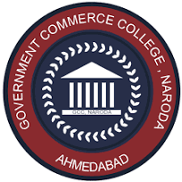
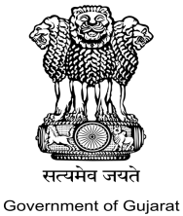
Government Commerce College
Behind Janseva Kendra, Manoharvilla Cross Road ,
Nikol Naroda Road, Naroda Ahmedabad -382346
Ph no: 079-22980772 Email Id:gccnaroda@gmail.com
_________________________________________________________________________ Date: 15 October 2025
Report on Workshop “Innovation to Implementation: Idea to Prototype”
Date: 11 October 2025
Venue:Government Commerce College, Naroda
Resource Person:Dr. Pritesh Khatri
No. of Participants:87

Government Commerce College, Naroda organized an insightful workshop on *Innovation to Implementation: Idea to Prototype* on 11 October 2025. The session was conducted as part of the institution’s continuous efforts to promote creativity, problem-solving skills, and entrepreneurial thinking among students. The workshop was delivered by Dr. Pritesh Khatri, an eminent academician and innovation expert known for guiding youth in design thinking, product development, and startup ideation.
The primary objectives of the workshop were:
- To introduce students to the concept of innovation and its relevance in the modern world.
- To provide a step-by-step understanding of the journey from idea generation to prototype development.
- To equip students with basic tools and frameworks used in design thinking and innovation.
- To motivate students to convert their creative ideas into feasible and sustainable solutions.
The workshop received an enthusiastic response from the students of Government Commerce College, Naroda. Many students actively participated in discussions and group activities. The interactive nature of the session helped them enhance their creativity, analytical ability, and confidence in presenting ideas.
Key Takeaways
- Innovation is a systematic process, not a sudden event.
- Every idea has potential if approached with critical thinking and structured methodology.
- Prototyping helps identify strengths, weaknesses, and possibilities for improvement before final implementation.
- Collaborative teamwork accelerates idea development and problem-solving.
- Conclusion

The workshop on Innovation to Implementation: Idea to Prototype proved to be highly informative and impactful. Dr. Pritesh Khatri’s expertise and engaging style made the session valuable for all participants. The college intends to organize more such workshops to promote innovation, entrepreneurship, and skill development among students.

Glimpse of Workshop

